##### Immunofluorescence staining

Cell Culture and Immunofluorescence Staining

Cells were seeded at a density of xxx × 10³ cells/cm² onto [18 mm] diameter round glass coverslips (Fisher Scientific, Waltham, MA, USA) placed in sterile 6-well tissue culture plates. Cultures were maintained in [e.g., DMEM supplemented with 10% fetal bovine serum and 1% penicillin–streptomycin] at 37°C in a humidified 5% CO₂ incubator for [e.g., 48 hours] to permit adhesion and spreading.

Following incubation, cells were washed three times in PBS at room temperature and fixed in 4% paraformaldehyde in PBS for [e.g., 20 min]. Fixed samples were washed in PBS and permeabilized using 0.1% Triton X-100 in PBS for [e.g., 10 min]. Non-specific sites were blocked with [e.g., 5% normal goat serum] in PBS for [e.g., 1 hour] at room temperature.

Cells were incubated overnight at 4°C with primary antibodies diluted in blocking buffer:

[e.g., rabbit anti-Protein A, 1:200, Cat# ab12345, Abcam, Cambridge, UK]

[e.g., mouse anti-Protein B, 1:500, Cat# 67890, Cell Signaling Technology, Danvers, MA, USA]

For negative control staining, species- and isotype-matched control IgG was used at equivalent concentration in place of the primary antibody:

[e.g., rabbit IgG, isotype control, Cat# 123456, Abcam]

[e.g., mouse IgG₁, isotype control, Cat# 98765, Cell Signaling Technology]

After three PBS washes, cells were incubated for [e.g., 1 hour at room temperature, protected from light] with highly cross-adsorbed fluorochrome-conjugated secondary antibodies:

[e.g., goat anti-rabbit IgG, Alexa Fluor 488, 1:1000, Cat# A-11008, Invitrogen]

[e.g., goat anti-mouse IgG, Alexa Fluor 546, 1:1000, Cat# A-11030, Invitrogen]

Nuclei were counterstained with [e.g., 1 μg/mL DAPI in PBS for 5 min], followed by PBS washes. Coverslips were mounted onto standard glass microscope slides using [e.g., Vectashield Antifade Mounting Medium with DAPI; Vector Laboratories, Burlingame, CA, USA]. Coverslips were sealed using clear nail polish and stored at 4°C in the dark until imaging.

**Confocal Microscopy and Image Acquisition**

Imaging was performed on an Olympus FV1000 inverted laser scanning confocal microscope (Olympus, Tokyo, Japan) equipped with a Plan-Apochromat 60×/1.42 NA oil immersion objective.

Fluorophores were excited using 405 nm, 488 nm, 543 nm, and 633 nm laser lines. To prevent spectral crosstalk, images were captured using sequential frame-by-frame scanning. Emitted fluorescence was collected by spectral detectors set to the appropriate ranges for each dye (e.g., 500–530 nm for Alexa Fluor 488; 555–655 nm for Alexa Fluor 543; >650 nm for Alexa Fluor 647). The absence of signal bleed-through was further verified by analyzing dual-color pixel fluorograms.

The confocal pinhole was set to 100 µm. Serial horizontal optical sections were acquired as 512×512 pixel frames with a pixel dwell time of 12.5 µs and 2× Kalman frame averaging. Z-stacks were captured through the entire cell thickness at 0.4 µm intervals, yielding a final voxel size of approximately 0.2 µm (lateral) × 0.8 µm (axial).

To ensure optimal signal-to-noise and prevent saturation, photomultiplier tube (PMT) high voltage (typically 600–700 V), gain, and offset were optimized for each channel using a “Hi-Lo” lookup table. These acquisition settings, along with laser power, were then held constant throughout each experiment. For each condition, a minimum of five cells of comparable size were imaged during the same session to ensure consistency and minimize variability.

**Image Processing and Quantitative Colocalization Analysis**

All confocal image data were processed using Olympus FluoView FV10-ASW software. For analysis and presentation, Z-stacks were rendered as maximum intensity projections.

Qualitative and quantitative colocalization analyses were performed on manually drawn regions of interest (ROIs) corresponding to individual cells. Qualitative assessment was performed using dual-color pixel fluorograms, where signal colocalization is indicated by pixels clustering along the diagonal, while non-colocalized signals form distinct populations along the x- and y-axes.

For quantitative analysis, the following metrics were calculated:

Pearson’s Correlation Coefficient (PCC): To measure the linear correlation between the pixel intensities of the two channels.

Manders’ Overlap Coefficients (M1 and M2): To determine the fraction of signal in one channel that co-occurs with signal in the other channel (e.g., M1 represents the fraction of green pixels that are also red).

Quantitative analysis was performed on at least five size-matched cells per experimental condition, and experiments were conducted three times independently. For figures, images were pseudocolored, merged, and assembled in Adobe Photoshop. Any adjustments to brightness or contrast for illustrative purposes were applied linearly and equally across all compared images.

Mander's coefficient gives a ratio of intensities in one channel relative to above-threshold regions in the other.

**M** - Colocalisation Coefficient (% pixels above thresholds colocolazed $\frac{B}{B+D}$

region (quadrant) D = pixels red only

region (quadrant) B = pixels red+green

qq B+D = total red

M is the sum of the intensities of red pixels that have a green component divided by the total sum of red intensities (all above thresholds).

*The images were exported to ImageJ public domain software (Wayne Rasband, National Institutes of Health, Bethesda, MD) and the pseudocolored Surface Plot three-dimensional presentation is obtained by combining 2D image with the value of pixel intensities presented in the z axis*

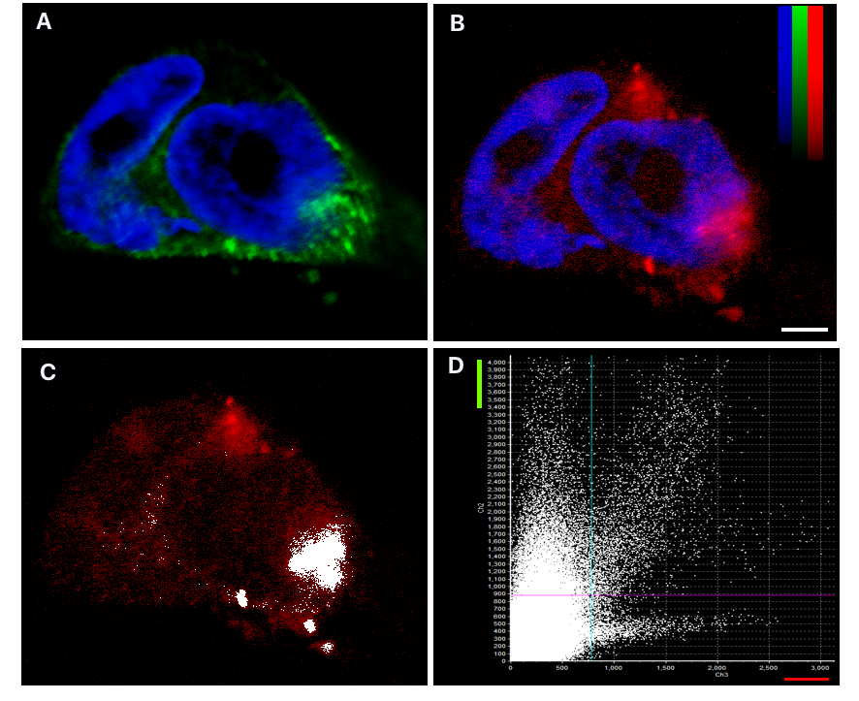

*Image par Marie Mc Coy; lab. Dr. Corbin*

Figure Legends (Template)

Figure X. Representative immunofluorescence images of Protein A and Protein B.

Maximum intensity projections of cells labeled for Protein A (green; Alexa Fluor 488) and Protein B (red; Alexa Fluor 546). Nuclei stained with DAPI (blue). Acquired using Olympus FV1000, 60× oil objective. Optical lateral resolution: ~0.2 µm; optical section thickness: ~0.8 µm. The color bar stands for the fluorescence intensity ranging. Scale bar = [e.g., 10 µm].

*The focal plane was adjusted to 2.2 µm distance from the-attached surface of the cell.*

Colocalization analysis of A in transfected cells expressing B: double-label confocal image with pixel fluorogram.

**(C)** The areas with high degree of colocalization of green-labelled **A** and red-labelled **B** appear yellow on merged image

**(D)** The distribution of dots along and near the axes indicates a distinct populations of Alexa 488 or Alexa 543 labelled **A**&**B**, which are not colocalizing.The colocalization of **A** with **B** resulted in points that predominantly fall along the diagonal line in the fluorogram.

*A lack of colocalization is shown by two distinct populations with a minimal overlap of dots distributed towards the red and green axes respectively .... these two populations in the fluorogram correspond to the signals derived from plasma membrane and from the intracellular portion, respectively*

# Macintosh HD 2:Users:leonid:Desktop:Modes d'emplois:Publiaide:Demo_Z.tif

# Fig. XX

Representative confocal photomicrographs are shown in three plans.

A: XY plan corresponding to single optical section at the level indicated by the yellow line in B & C.

B & C : The XZ and YZ planes, respectively. Yellow lines represent coordinates of each plane in A.

*1 ( Demandolx D, Davoust J. (1997) Multicolour analysis and local image correlation in confocal microscopy. J Microsc 185:21–36 )*

*2 (Manders, E. M. M., F. J. Verbeek, and J. A. Aten. 1993. Measurement Of Colocalization Of Objects In Dual-Color Confocal Images. J. Microsc. 169:375–382)*

✅ Notes for Users

All placeholders ([e.g., …]) must be replaced with exact experimental details in actual submissions.

Report antibody controls with the same rigor as primary antibodies: catalog number, concentration, source.

Adjust acquisition parameters to achieve the required lateral and axial resolution per your imaging goal; use objective NA and emission bandwidth to estimate.